Sri Lanka Institute of Information

Technology

Lab Submission

Lab sheet No 04

**IT24101575**

**Arham S.M**

**Probability and Statistics | IT2120**

B.Sc. (Hons) in Information Technology

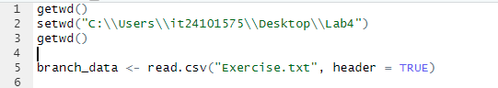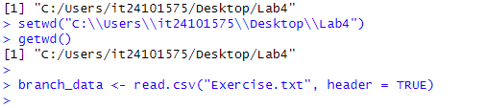



Sales (X1) - *Quantitative, Continuous, Ratio scale* (sales in numeric values).

Advertising (X2) - *Quantitative, Continuous, Ratio scale* (measured in dollars).

Years (X3) - *Quantitative, Discrete, Ratio scale* (count of years).



